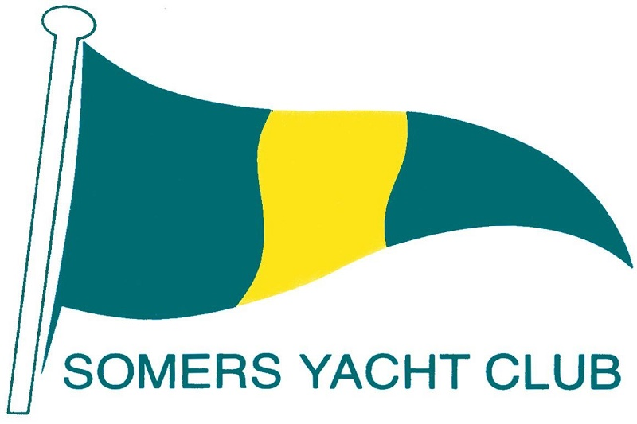
Somers Yacht Club Inc. 7635
99 Alexandra Avenue
Somers 3927

CLUBHOUSE BOOKING ENQUIRY FORM

Name:
Address: Postcode:
Postal Address: Postcode:
Phone: Mobile: Email:

Function Details (Type of event, Catering etc.)

Private:
Corporate:
Community:
Number of Guests:

Date

1st Choice: Time in: Time Out:
2nd Choice: Time in: Time Out:

SsYC Membership Details

Member: Number of Years: Non Member:

Note: Non Member Bookings require sponsorship by a Membership

Sponsoring Member’s Name:

Signature: Date:

Please forward to: Somers Yacht Club, PO Box 129, Somers 3927
or email Cameron Harvey: bookings@somersyachtclub.com

On receipt of the completed from, the SsYC committee will notify you of the club’s availability, rates and terms and Conditions.

Cameron Harvey - Booking Officer

